**LAB TASK # 2**

**Question # 1 :**

**INPUT:**

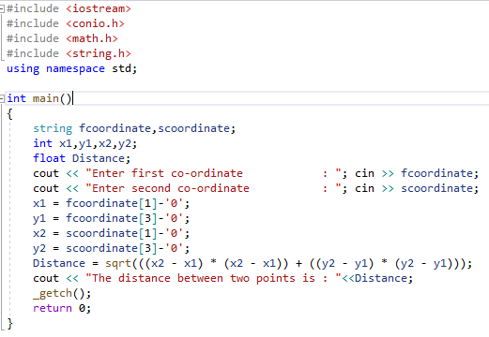

**OUTPUT:**



**Question # 2 :**

**INPUT :**

**MATRIX ADDITION**

#include <iostream>

#include <conio.h>

#include <math.h>

#include <string.h>

using namespace std;

int main()

{

int i, j, a[3][3], b[3][3], sum[3][3];

for (i = 0; i < 3; i++)

for (j = 0; j < 3; j++)

{

cin >> a[i][j];

}

for (i = 0; i < 3; i++)

for (j = 0; j < 3; j++)

{

cin >> b[i][j];

}

for (i = 0; i < 3; i++)

for (j = 0; j < 3; j++)

{

sum[i][j] = a[i][j] + b[i][j];

}

for (i = 0; i < 3; i++)

for (j = 0; j < 3; j++)

{

cout << sum[i][j] << "\t";

if (j == 2)

cout << endl;

}

}

**MATRIX MULTIPLICATION**

#include <iostream>

using namespace std;

int main()

{

int a[9][9] = { {1,2,3},{4,5,6},{7,8,9} };

int b[9][9] = { {9,8,7},{6,5,4},{3,2,1} };

int mul[9][9] = { {0,0,0},{0,0,0},{0,0,0} };

int i, j, k;

for (i = 0; i < 3; i++)

{

for (j = 0; j < 3; j++)

{

mul[i][j] = 0;

for (k = 0; k < 3; k++)

{

mul[i][j] += a[i][k] * b[k][j];

}

}

}

for (i = 0; i < 3; i++)

{

for (j = 0; j < 3; j++)

{

cout << mul[i][j] << " ";

}

cout << "\n";

}

}

**OUTPUT :**

**MATRIX ADDITION**

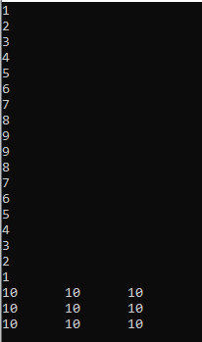

**MATRIX MULTIPLICATION**

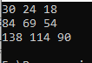

**Question # 3 :**

**INPUT :**

#include<iostream>

using namespace std;

struct student {

char fname[20];

char lname[20];

double score;

};

int main() {

student obj1;

cout << "Enter first name : " ;

cin >> obj1.fname;

cout << "Enter last name : " ;

cin >> obj1.lname;

cout << "Enter score : " ;

cin >> obj1.score;

cout << endl;

cout << "Description of student" << endl;

cout << "First name : " << obj1.fname << endl;

cout << "Last name : " << obj1.lname << endl;

cout << "MARKS : " << obj1.score << endl;

}

**OUTPUT :**

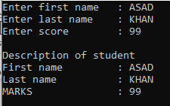

**Question # 4 :**

**INPUT :**

#include<iostream>

using namespace std;

struct student

{

char fname[20];

char lname[20];

double score;

};

student getdata(student obj1)

{

cout << "Enter first name : ";

cin >> obj1.fname;

cout << "Enter last name : ";

cin >> obj1.lname;

cout << "Enter score : ";

cin >> obj1.score;

return obj1;

}

int main() {

student obj1 = { "ASAD","ALI",87 };

cout << "Description of student 1" << endl;

cout << "First name : " << obj1.fname << endl;

cout << "Last name : " << obj1.lname << endl;

cout << "MARKS : " << obj1.score << endl;

student obj2 = getdata(obj1);

cout << endl;

cout << "Description of student 2" << endl;

cout << "First name : " << obj2.fname << endl;

cout << "Last name : " << obj2.lname << endl;

cout << "MARKS : " << obj2.score << endl;

}

**OUTPUT :**

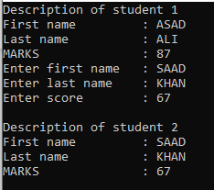

**Question # 5 :**

**INPUT:**

#include <iostream>

#include <conio.h>

#include <string.h>

using namespace std;

struct address

{

string house_no;

string city;

int pin_code;

};

struct employee

{

int emp_id;

string name;

int salary;

address a1;

};

int main()

{

employee e1;

e1.emp_id = 100;

e1.name = "Asad Ali Khan";

e1.salary = 30000;

if (e1.salary < 50000)

{

e1.salary = e1.salary * 1.1;

}

e1.a1.house_no = "R-4";

e1.a1.city = "Karachi";

e1.a1.pin_code = 79760;

cout << "Details of Employees" << endl;

cout << endl;

cout << "Employee ID : " << e1.emp_id << endl;

cout << "Employee Name : " << e1.name << endl;

cout << "Employee Salary : " << e1.salary << endl;

cout << "Employee House no : " << e1.a1.house_no << endl;

cout << "Employee City : " << e1.a1.city << endl;

cout << "Employee Pin Code : " << e1.a1.pin_code << endl;

}

**OUTPUT:**

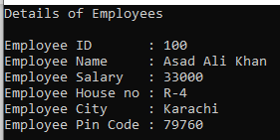

**Question # 6 :**

**INPUT :**

#include <iostream>

#include <conio.h>

using namespace std;

int sum(int* pt1, int* pt2)

{

int result;

result = *pt1 + *pt2;

return result;

}

int diff(int* pt1, int* pt2)

{

int result;

result = *pt1 - *pt2;

return result;

}

int mul(int* pt1, int* pt2)

{

int result;

result = *pt1 * *pt2;

return result;

}

int div(int* pt1, int* pt2)

{

int result;

result = *pt1 / *pt2;

return result;

}

int main()

{

int num1, num2;

int* pt1, * pt2;

cout << "Enter value for number 1 :"; cin >> num1;

cout << "Enter value for number 2 :"; cin >> num2;

pt1 = &num1;

pt2 = &num2;

string a;

cout << "Which operation you want to perform :"; cin >> a;

if (a == "add" || a == "Add" || a == "ADD")

{

cout << "The sum of number 1 and number 2 is : " << sum(&num1, &num2) << endl;

}

else if (a == "sub" || a == "Sub" || a == "SUB")

{

cout << "The diff of number 1 and number 2 is : " << diff(&num1, &num2) << endl;

}

else if (a == "mul" || a == "Mul" || a == "MUL")

{

cout << "The mul of number 1 with number 2 is : " << mul(&num1, &num2) << endl;

}

else if (a == "div" || a == "Div" || a == "DIV")

{

cout << "The div of number 1 by number 2 is : " << div(&num1, &num2) << endl;

}

_getch();

return 0;

}

**OUTPUT :**

